**RAPTOR FLOWCHARTS**

**Name:** P.Geetesh

**Roll No:** CH.SC.U4CSE24136

1. **Volume of a cuboid**

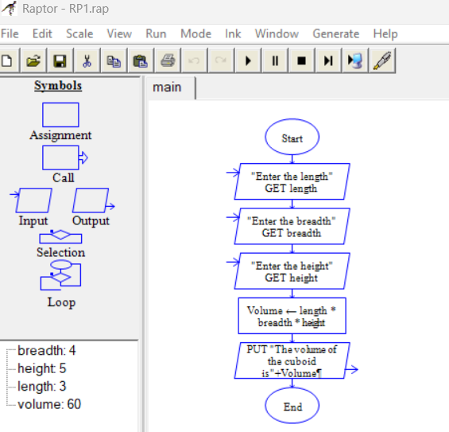

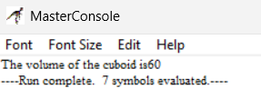

1. **Temperature converter from Celsius to Kelvin**

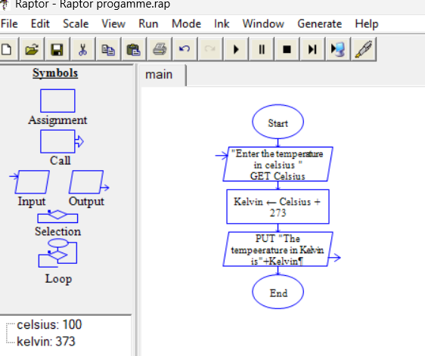

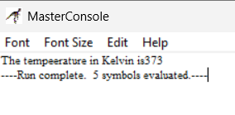

1. **Calculation of Grades through Marks**



